[](http://www.google.co.uk/url?sa=i&rct=j&q=&esrc=s&source=images&cd=&cad=rja&uact=8&ved=2ahUKEwj5wMrChu_bAhUJthQKHdiiCJsQjRx6BAgBEAU&url=http://www.schoolsrugby.co.uk/School.aspx?ID%3D915&psig=AOvVaw3n73T2JNazUqTJShJQkVkh&ust=1530024213642494)

**Uniform Policy**

MONITORING AND EVALUATION OF POLICY

This policy will be reviewed annually.

It is our school policy that all students wear our school uniform when attending school, or when participating in a school-organised event outside normal school hours. We provide a complete list of the items needed for school uniform in our school prospectus and on our website.

Aims and objectives

Our policy on school uniform is based on the notion that school uniform:

* Promotes a sense of pride in our school;
* Engenders a sense of community and belonging towards the school;
* Is practical and smart;
* Identifies the students with the school;
* Prevents students from coming to school in clothes that could be distracting in class;
* Makes students feel equal to their peers in terms of appearance;
* Is regarded as suitable wear for school and good value for money by most parents/carers;
* Is designed with health and safety in mind.

**Uniform at Cefn Saeson**

KS3 (Year 7 & 8) uniform includes the **school Jumper**, white shirt, school tie and black trousers/skirt.

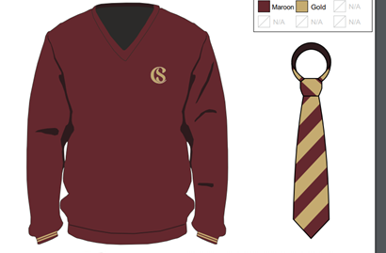

KS4 (year 9 – 11) uniform includes the **school blazer**, white shirt, school tie and black trousers/skirt.

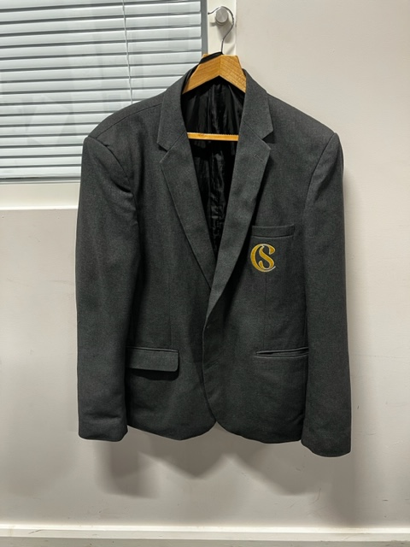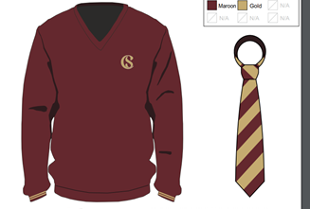

The school jumpers (ks3) and blazers (ks4) are available from Sportec in Neath Abbey. However, Cefn Saeson operates a uniform upcycle scheme where pupils donate their jumpers/blazers to pass on to pupils at no charge.

* School trousers must be black and tailored. We allow various styles, and a slim leg is acceptable, although skinny jeans, trousers containing rivets/studs or **leggings are not permitted**.
* Plain black, leather (not canvas), flat shoes or trainers. Black trainers with white soles are not permitted.
* If a student chooses to wear a hijab for religious reasons it is to be black, grey or burgundy
* Dark coloured outer coat (waterproof is advisable). Wearing hooded tops or sports jacket as school coats are not allowed.
* Jewellery should be kept to a minimum: a **single set of stud earrings** to be worn in the ear. **No facial piercings** of any nature are allowed. Failure to remove piercings will result in the jewellery being confiscated. **No rings, necklaces or bracelets** are allowed.
* Nails must be maintained at a short length due to health and safety regulations for P.E. and practical subjects such as Food Technology and Science.

**Physical Education Kit**

* Cefn Saeson Outdoor PE top
* Cefn Saeson school logo T-shirt
* Black shorts/tracksuit bottoms/ leggings/Skort
* Wine/Grey sports socks
* Gym shoes/ Trainers

A note must be provided in an envelope if a pupil needs to be excused from a PE lessons

**Mobile phones/MP3 Players**

We do not allow mobile phones at all during the school day. Please refer to the mobile phone policy with regard to the process in place if students are seen with their mobile phones in school

Additionally, no student is permitted to have their earphones/ear pods on at any time during the school day. The same process applies as per the mobile phone policy. Phones and ear pods will be confiscated by staff should they be seen.

**The role of parents/carers**

We ask all parents/carers who choose our school to support the school uniform policy. We believe that parents/carers have a duty to send their child to school correctly dressed and ready for their daily schoolwork.

If any parent would like the school to modify the uniform policy, they should make representation, in the first instance, to the Headteacher. The school welcomes young people from all backgrounds and faith communities. If there are serious reasons, for example on religious grounds, why parents/carers want their child to wear clothes that differ from the school uniform, the school will look sympathetically at such requests.

**The role of the student**

We expect all students to represent the school by wearing the correct school uniform.

**The role of staff**

We ask all staff to support the Headteacher in implementing the school uniform policy and sharing the same expectations for Cefn Saeson

**The role of the Governors**

The Governing Body supports the Headteacher in implementing the school uniform policy. It considers all representations from parents/carers regarding the uniform policy and liaises with the Headteacher to ensure that the policy is implemented fairly and with sensitivity. It is the Governors’ responsibility to ensure that the school uniform meets all regulations concerning equal opportunities. Governors ensure that the school uniform policy helps students to dress sensibly, in clothing that is hardwearing, safe and practical.

**Consequences of wearing non-school uniform.**

Pupils who do not comply with the school uniform are first given a warning, and parents will be informed of the uniform code. Sanctions may be implemented due to infringing the uniform code.

Pupils who fail to meet the uniform code can be

1. Sent home to change and acquire the correct school uniform and return to school
2. Removed from the classrooms and placed into the PAWB Wellbeing room until uniform is worn.

**Monitoring and review**

The Governing Body monitors and reviews the school uniform policy through its committee work by:

* seeking the views of parents/carers, to ensure that they agree with and support the policy;
* considering, with the Headteacher, any requests from parents/carers for individual students to have special dispensation with regard to school uniform;
* requiring the Headteacher to report to the Governors on the way the school uniform policy is implemented.

Document Ratification

This Policy was presented to Governors on 7th December 2023

It will be reviewed in Autumn 2024 or if National and Local Policy or Guideline is updated.

Reviewed 3rd October 2024

Signed

Cllr P Rees

Chair of Governors