**Governors School Improvement Committee R 4**

**Tuesday 28th November 2023 at 4.30 pm**

PRESENT: Mrs R Reed

Mrs C Loaring

Mr J Yeomans

Mrs Reed led and opened the meeting and gave the below presentation to the committee.

The meeting concluded at 4.55 pm

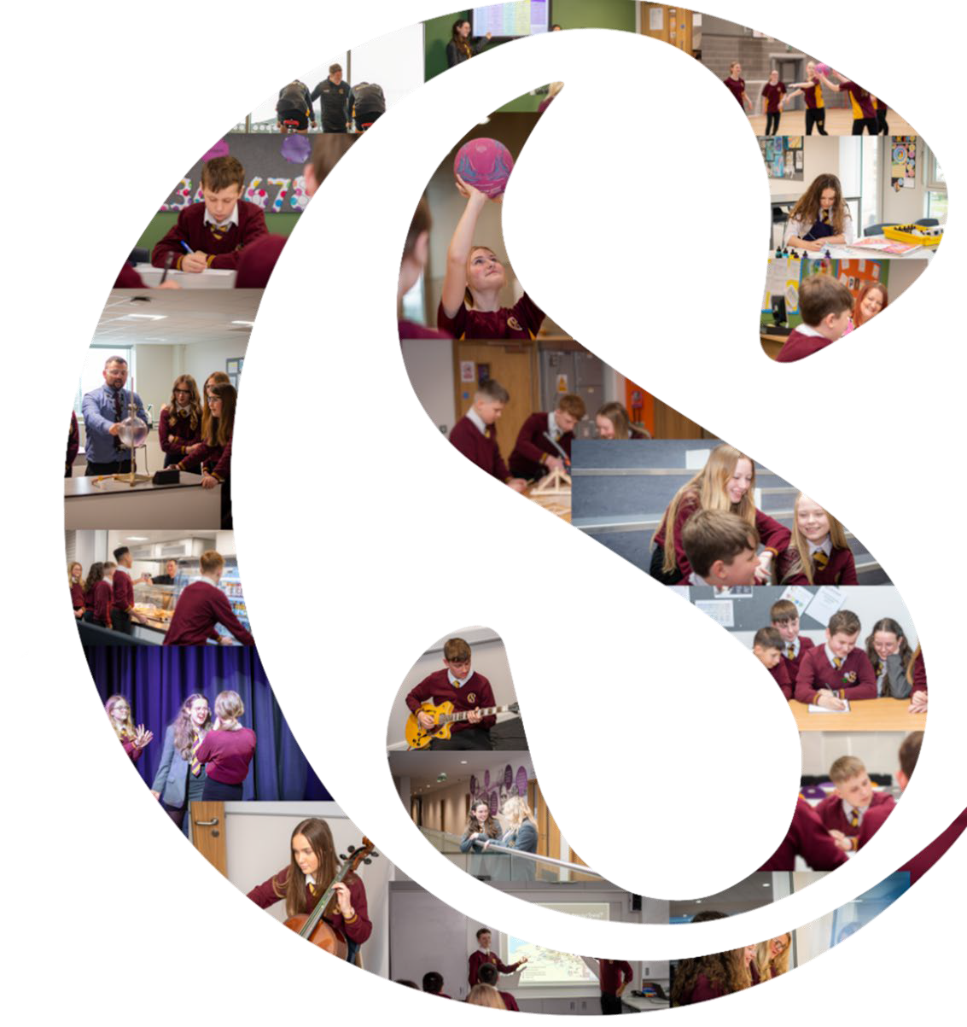

# PIAP:

GSIC Autumn Report 2023

*Progress Against Estyn Recommendation 4*

PIAP Activity

***R4: Ensure that all pupils have access to the full breadth of provision, particularly the provision for Welsh, English in Year 11 and PSE in Key Stage 4***

Estyn Identified that:

*Welsh - In general, pupils do not make sufficient progress in their Welsh language skills. This is largely due to the lack of provision, particularly in Key Stage 4*

*PSE - There has been limited provision for PSE in Year 10 so far this year. As a consequence, pupils have not had sufficient opportunity to learn about important aspects of health and well-being.*

*English - A few more able pupils do not have suitable provision in English from January onwards in Year 11.*

## Welsh

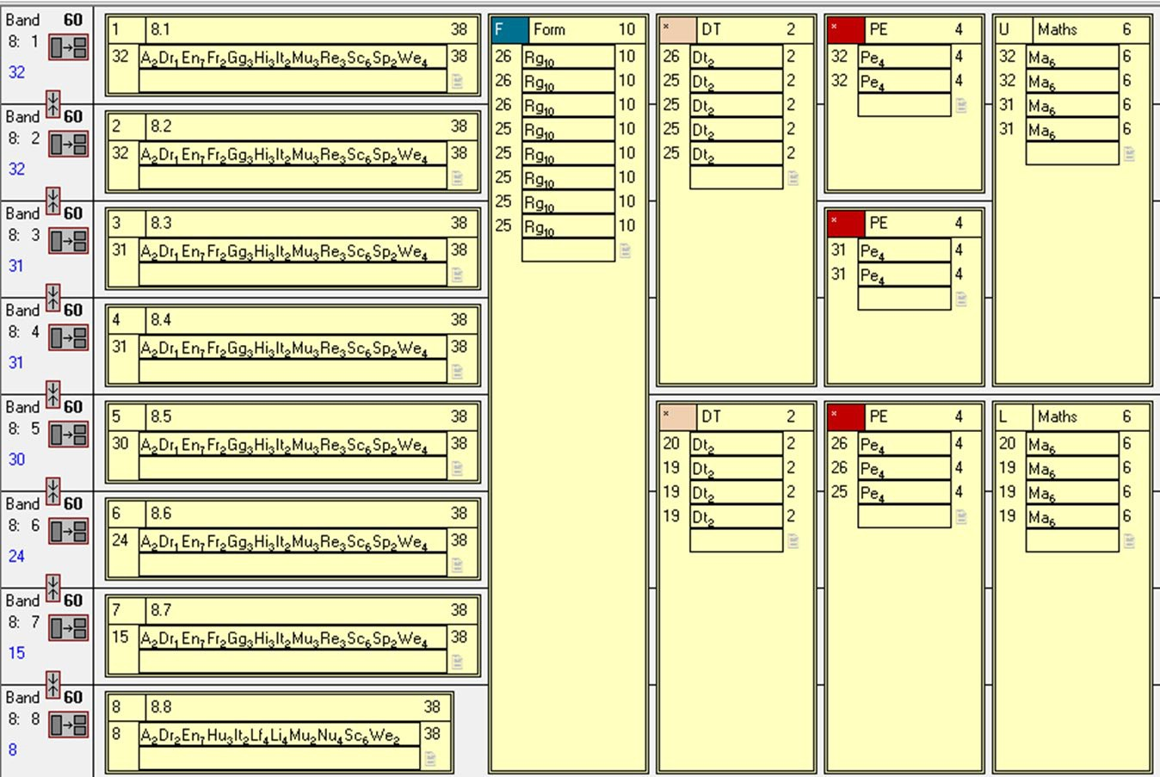

Key Stage 3 provision ***increased*** to 4 hours per week

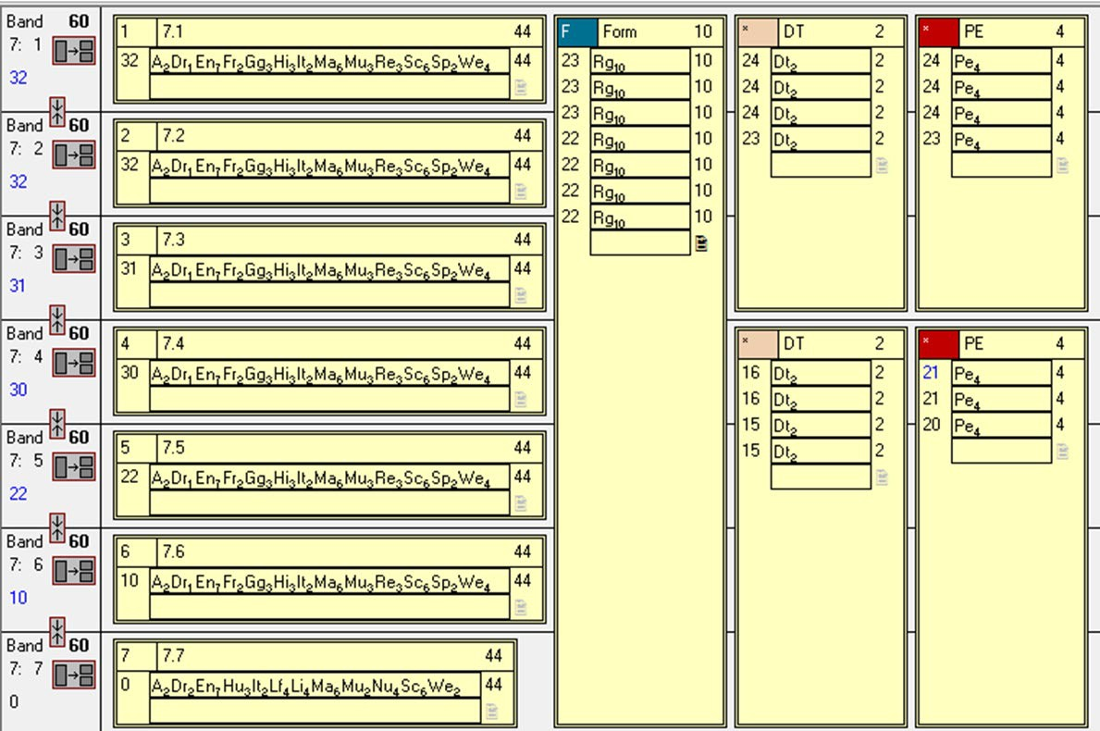

The rationale behind the increased provision is to build enthusiasm and passion for Wales and the Welsh language through engaging learning activities, building a firm foundation for key stage 4 GCSE assessment requirements

Key stage 4 provision has *increased* to 3 hours per fortnight to meet the guided learning hours of WJEC GCSE specification

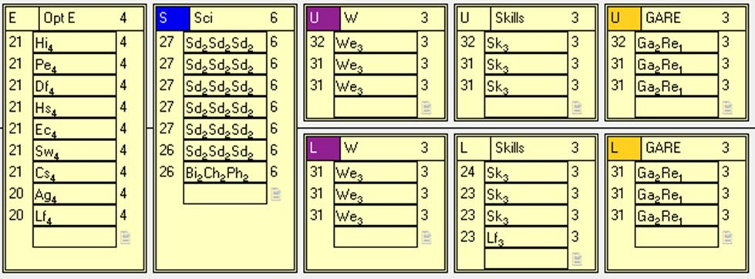

In order to facilitate the increased provision we currently have we have 4 members of staff teaching across both key stages. To sustain the increased provision we have also successfully appointed a Welsh and Drama teacher who will start in September 2024.

Year 11 - majority pupils will be studying towards WJEC GCSE, because of the provision in previous years other pupils will be studying Entry Level (with the exception of pupil dis-supplied through ALN IDP)

Year 9 & 10 - most pupils are studying towards WJEC GCSE - with exception of a very few who will be studying Entry Level or has been dis-supplied through ALN IDP. To enable this increased provision

## PSE

To increase the opportunity to learn about important aspects of health and well-being key stage 4 pupils receive regular timetable sessions of PSE in line with key stage 3 provision.

PSE is taught across all year groups by form tutors on Wednesday week 2 Lesson 1.

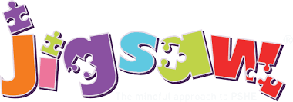During the allocated PSE session pupils follow the whole school ‘Jigsaw’ programme of study

Jigsaw connects the pieces of Personal, Social, Health and well-being education prioritising the needs of our young people as identified in our SHRN survey.

The programme teaches young people emotional literacy, social and lifelong skills, RSE and resilience in an age appropriate manner

**2023-24 PSE Lesson Jigsaw Programme Overview**

**Provision: Wednesday (week 2) form time and lesson 1.**

|  |  |  |  |  |  |
| --- | --- | --- | --- | --- | --- |
| **Term**  **time** | **Jigsaw topic** | **Year**  **Group** | **Lesson** | **Jigsaw**  **Piece** | **Sub topic** |
| **Autumn Term** | | | | | |
| Sept - Oct | Dreams and Goals (D&G) | 7 | 1 | 1 & 2 | What are my D&G; Achieving my D&G |
| 2 | 3& 4 | Coping strategies; how responsible &  irresponsible choices affect my D&G |
| 3 | 5 | How making an irresponsible choice could  affect a persons D&G |
| 4 |  | Complete any lessons unfinished or choose  another lesson to complete |
| 8 | 1 | 1 | Your Goals – Long Term |
| 2 | 3 | Online Safety |
| 3 | 4 | Money & earnings |
|  | 4 |  | Complete any lessons unfinished or choose  another lesson to complete |
| 9 | 1 | 2 | The power of planning |
| 2 | 4 | Mental health & illness |
| 3 | 5 | Media manipulation & mental health |
|  | 4 |  | Complete any lessons unfinished or choose  another lesson to complete |
| 10 & 11 | 1 | 1 | Relationships and goals |
| 2 | 2 | Me, my goals & my health |
| 3 | 3 | Work/life balance |
|  | 4 |  | Complete any lessons unfinished or choose  another lesson to complete |
| Nov - Dec | Being Me in My World | 7 | 1 | 1&2 | Who am I & My Influences |
| 2 | 3 | Peer Pressure & Belonging |
| 3 | 4&5 | Online identity& consequences of what I say  or do online |
| 8 | 1 | 1 | Who am I? |
| 2 | 4 | First Impressions |
| 3 | 5 | Faith & beliefs |
| 9 | 1 | 2 | Expectations and perceptions of relationships |
| 2 | 4 | risk |
| 3 | 5 | consent |
| 10 & 11 | 1 = 1 | 1 | Liberty & Safety in My World |
| 2 | 3 | How social media affects me, my identity and  culture |
| 3 | 4 or 5 | Rated/Risks |
| **Spring Term** | | | | | |
| Jan - Feb | Celebrating Difference | 7 | 1 | 1 | Prejudice & discrimination |
| 2 | 3 | Challenging stereotype |
| 3 | 5 | Bullying |
| 8 | 1 | 1 | Prejudice & discrimination |
| 2 | 2 | Injustice |
| 3 | 4 | Bullying |
| 9 | 1 | 1 | Equality |
| 2 | 2 | Understanding Difference |

In addition to the PSE lesson pupils also have a comprehensive programme that is delivered by external providers during ‘shut-down’ days.

|  |  |  |  |  |  |  |
| --- | --- | --- | --- | --- | --- | --- |
|  | **1** | **2** | **3** | **4** | **5** | **6** |
|  | **Sept - Oct** | **Nov - Dec** | **Jan - Feb** | **Feb - March** | **April - May** | **June - July** |
| **Yr 7** | R.W. Communication  19th & 20th Oct | SHRN  20th Nov – 1st Dec in IT lessons | Debbie Harris – Body Parts  7th & 8th Feb | Adferiad | Reaching Wider  Career Workshop | Reaching Wider Taster  session |
| **Yr 8** | Fire Service 3rd Oct | SHRN  20th Nov – 1st Dec in IT lessons Team Building  7th & 8th Nov | Careers – Options with Rebecca M  11th & 12th Jan  Reaching Wider Careers | Adferiad | Healthy Relationships 9th May | Reaching Wider Taster session |
| **Yr 9** | Ash Wales Assembly 17th Oct | SHRN  28th Nov IT3 (L1-5) & LRC (L3-  5)  R.W. Problem Solving 4th & 5th  Dec | Nurse Contraception 18th & 19th Jan | Reaching Wider Careers workshop | Nurse STIs 24th & 25th April | Young Carers 3rd & 4th July |
| **Yr 10** | Delyth PoP Sexual Harassment & UPSTREAM questionnaire (Leanne) 20th October  ASH Wales Assembly Work Experience Assembly  25th Oct | SHRN  PSE lesson 1 - chromebooks Reaching Wider Revision 4th Dec |  | Career Check 18th & 19th March | Youth Service – Leanne  14th & 15th May | Interview Prep Careers Wales  27th & 28th June Mock Interviews 2nd July |
| **Yr 11** | Careers Wales ‘Choose Your Future’ event  5th Oct  Ash Wales Assembly 16th  October | SHRN  PSE lesson 1 - chromebooks Reaching Wider Revision 18th Dec | Car Crash Scene 11th Jan | Delyth Mental Health First Aid |  |  |
| **Additional events** | SRTC 20th Oct Black History month | 11th Nov Remembrance | Holocaust Memorial (27th Jan)  Internet Safety 6th Feb Childrens Mental Health  week 5th – 11th Feb | International Womens Day (8th March) | LGBTQ month |  |

# English

2023 onwards **no** pupils are entered early for English language or literature to ensure that ***all*** pupils receive the full guided learning hours as specified by the WJEC.

# Next Steps

Reviewing progress’ self-evaluation activities to monitor progress and impact. **Reference to R1,R3**

* Does the provision for Welsh (at key stage 4) give pupils sufficient opportunity to make progress in their welsh skills?
* Does the provision for PSE (in ks4 particularly) give pupils sufficient opportunity to learn about important aspects of health and well- being?