**Present** Councillor P Rees

Mrs J Lewis

Mrs M Talbot

Mrs J Cotgias

Mr D Cole – Headteacher

Mrs A Powis – Clerk to the Governors

1. **Apologies for Absence**

The clerk gave apologies for the absence of Mr S John, Mr M Protheroe and Councillor S Penry.

*Governors accepted the apologies.*

1. **Closing Budget 2022 / Budget Pressures moving forward / Opening Budget 23/24**

The Head noted that the agenda had 3 points which he amalgamated together.

Governors were given the budget spreadsheet which the Headteacher went through in detail. The reserve that the school ended in March 2023 for the financial year of 2022/2023 was £168,816 in credit, the school was not in debt.

The Head reported that the budget is not very good this year and schools have struggled with setting a budget for 23/24. The school have planned to spend and the Head warned governors that we could be looking at a deficit budget by 2024.

For the school to set the budget, the LEA had us to predict the salary rise for Teaching staff, so the school has had to set a budget of an overspend of £240k by the end of 2024. Attached is the spreadsheet of what has been sent into the authority.

The Head explained that utilities are going to be covered by the LEA, as they have gone up. The school have budgeted for a 50% rise, but they are going to overrun by around £57k. The director has promised schools that this will come back to us.

The Head relayed that the LEA are going to be giving schools an extra £100k to help towards the behaviour of pupils.

The school have tried to cover an English teacher who will be going on maternity leave by a teacher in the SENC, so the school have not increased the teaching staffing.

The school will end with an in year deficit. Our budget did involve us cutting staff, Teaching Assistants and 2 Teachers. The School will probably end with an in year deficit of around £200k

*Governors accept the budget for 2023/2024 and the update on current budget on looking at an in year deficit of around £200k*

1. **AOB**

No other business.

Meeting concluded at 3.36 pm

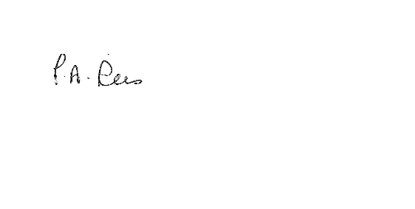

Councillor P Rees

Chair of Governors