Dear Parent/Guardian and Pupil

Year 11 November Examinations 2020

I am writing to inform you of the arrangements for the Year 11 November mock examinations. If pupils are not required to sit an exam, they will not be sent home and will follow their normal timetable.

All pupils are expected to attend examinations - written, speaking and practical – in full school uniform, and normal rules will apply regarding jewellery, make up and body piercings.

If a pupil misses a mock examination, they will be required to sit the examination at the earliest possible opportunity. If there is no valid reason for their absence, then they will be expected to sit the examination after school.

The timetable for the examinations can be found on the reverse of this letter and I would like to wish your child the best of luck in their revision efforts and of course for the upcoming examinations.

Results day will be on Wednesday the 16th December, and pupils will receive a mock examination results letter with their grades. If you have any questions that I may help with, please contact me at the school.

Kind regards
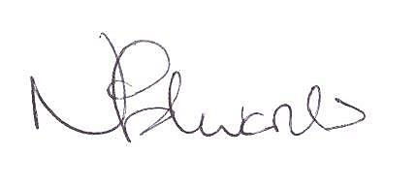
Mrs N Edwards
Examinations Officer

